BONNEVILLE DAM
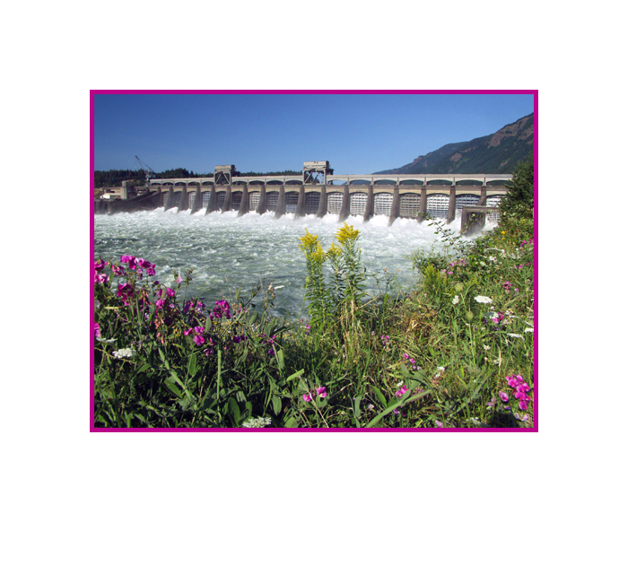
FISHWAY STATUS ANNUAL REPORT

2008

By

Ben J. Hausmann
Jonathan G. Rerecich
Kasey M. Welch

U. S. Army Corps of Engineers
CENWP-OP-B
Bonneville Lock & Dam
Cascade Locks, OR 97014
(541) 374-4552

31 January 2009
TABLE OF CONTENTS

INTRODUCTION-----------------------------------------------------------------------------------2
Figure 1. Bonneville Lock and Dam--------------------------------------2

FISHWAY OPERATION AND ACTIVITIES----------------------------------------------3-6
Fish Passage Plan (FPP) Violations-----------------------------------------------3
Table 1. Fish passage plan violations and percent in criteria--------3
STS/VBS Inspections-------------------------------------------------------------------5
Table 2. STS and VBS Inspections 2005-2006-----------------------------5
Zebra Mussels-----------------------------------------------------------------------------5
Avian Abatement Measures----------------------------------------------------------5
Auxiliary Water System (AWS) Closures-----------------------------------------6
Table 3. Fish valve closures and closure times---------------------------6
Fish counts---------------------------------------------------------------------------------6
Adult Fishway Temperature Monitoring------------------------------------------7
Table 4. Daily average temperatures for Bradford Island----------------7
Table 5. Daily average temperatures for Washington Shore------------7
Table 6. Daily average temperatures for the AFF---------------------------7
Table 7. Daily average temperatures for JMF--------------------------------7
FISH FACILITY AND TURBINE OUTAGES-------------------------------------------8-10
Table 8. Fish Facility Outages & Maintenance-----------------------8
Table 9. Fish Unit Outages--------------------------------------------------9
Table 10 . Turbine Outages of at least 24 hours ------------------10

FISH REMOVAL----------------------------------------------------------------------------------11

RECENT FISHWAY MODIFICATIONS------------------------------------------------12-14

GLOSSARY----------------------------------------------------------------------------------------15

REFERENCES------------------------------------------------------------------------------------16

INTRODUCTION
The 2008 Fishway Status Annual Report for Bonneville Lock and Dam summarizes activities impacting fish at Bonneville from 1 December 2007 through 30 November 2008.

Primarily a summary of weekly reports, this document summarizes all activities affecting fish passage including maintenance outages, dewaterings and recent modifications to fishway components. This document is required by the Corps of Engineers’ Northwestern Division, as described in the Fish Passage Plan (FPP). The FPP contains the following reporting requirements: “The (weekly) reports shall include: any out of criteria situations observed and subsequent corrective actions taken; equipment malfunctions, breakdowns or damage, along with a summary of resulting repair activities; adult fish control calibrations; STS and VBS inspection; any unusual activities which occurred at the project which may affect fish passage.” Project biologists perform inspections of the fish passage facilities three times per day and seven days per week during fish passage season and three times per day at least three times per week during winter maintenance season as outlined in the FPP.

The Project includes two powerhouses, a spillway and two navigation locks. The older of the two navigation locks has not operated since early 1993. There are four adult fish ladders, for upstream migration, located at each powerhouse and the north and south ends of the spillway. There are three Juvenile Bypass Systems (JBS) for downstream migration: an Ice and Trash Sluiceway (ITS) at Powerhouse 1 (PH1), a downstream migration transportation channel (DSM) at Powerhouse Two (PH2), and the PH2 corner collector at (B2CC).

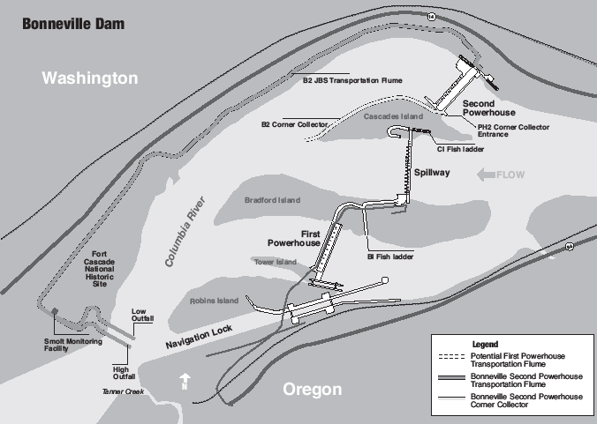
Figure 1. Bonneville Lock & Dam.

FISHWAY OPERATION AND ACTIVITIES
Fish Passage Plan Violations
The results of 314 daily fishway inspections, 9 conducted by National Oceanic and Atmospheric Administration (NOAA) Fisheries, or the Fish Passage Center (FPC), are shown in the following table. Project Fisheries and the control room operators conduct inspections each day. Shown are the FPP violations and the percentage of days the item was in criteria based on Project Biologist’s inspections only. Items in criteria 100% of the time are not listed.

Table 1. Fish Passage Plan violations and percent in criteria.
Out of criteria details
The following paragraphs are explanations for items that were out of criteria more than 80% of the reporting year.

At PH1, the velocity meter is placed in an eddy in the slowest part of the collection channel. Due to this placement, Project Fisheries used the mechanical velocity meter as the primary indicator of velocity. The mechanical meter was in criteria 100% of the time.

In April, the PH2 velocity meter was found to be reading incorrectly. The Project is investigating replacement or relocation.

A-branch weir staff gauge was reading >1.0’ during the spring, mostly in May and June, likely due to high tailwater. The ladders were also taken out of shad passage mode early due to low numbers of shad, so the weir was out of criteria from 31 July until 15 August.

A-branch diffusers were frequently out of criteria during fish passage season. FG3-5 failed to operate in April, and was out of criteria when tailwater was above 16.7’ msl. The diffuser is scheduled to be repaired during the winter of 2008/2009.

PH1 Collection Channel diffusers were out of criteria the entire fish passage season. FG2-19 and FG2-22A failed to open at water-up in 2006. The collection channel, however, remained within FPP criteria. These diffusers are scheduled to be repaired during the winter of 2009/2010.

The B-branch fishway was in manual during most of the reporting year, resulting in diffusers frequently being out of criteria. The diffusers were adjusted manually on daily inspections, as necessary.

Cascades Island diffuser FG6-10 motor and shaft separated due to mechanical failure. Other diffusers were used to compensate when appropriate. Repairs are scheduled for winter 2008/2009.

Spillway bays were out of criteria from 27 May until 03 September due to Spillbay 15 hoist failure. The spill pattern was adjusted until the hoist could be repaired to maintain the appropriate rate of river discharge through the spillway and egress conditions in the tailrace.

The PH2 floating orifice gates (FOG) have been out of criteria since 01 March 2008. Stab plates were installed in the FOGs until new sea lion exclusion devices (SLEDs) were manufactured. Installation began on 21 March, but SLEDs were only installed in the four larger FOGs due to a broken lifting beam.

The DSM2 airburst system had a program malfunction the entire year. Due to a program issue, screens 6 and 9 would not operate in the automatic cycle. The project compensated for this by utilizing the mechanical screen cleaners and bursting screens manually. With this combined effort, there was no debris accumulation on the screens.

STS/VBS Inspections
Submersible traveling screen (STS) and vertical barrier screen (VBS) are inspected once a month. Each STS has a timer that automatically shows elapsed time of operation, with one month of continuous operation equaling 720 hours. Bonneville uses an underwater video camera to inspect STSs and VBSs simultaneously. This gives the project the ability to inspect the screens while they are installed and while the unit is running, and has eliminated the need to dip gatewells.

Table 2. STS and VBS Inspections 2007-2008

Screens are installed in Unit 1 and Unit 3 from 15 September until at least 15 December for adult fallbacks. The modification of the ice and trash sluiceway has been postponed until winter 2008/2009, when automated gates will be installed. The removing of the wall that divides the sluiceway from DSM1, and sloping the floor is postponed until winter 2009/2010. These improvements will increase survival rates of out-migrating juveniles by providing a more effective surface bypass route.

Zebra/Quagga Mussels
Through weekly inspections of the monitoring station at the PH1 and of all dewatered fishways, we have found no indication of zebra or quagga mussel colonization. It is widely believed that their arrival is inevitable. The Project stays involved in regional preparation for zebra/quagga mussel arrival by sending project personnel to training and seminars to stay abreast of the latest information concerning these invasive species. We continue monitoring with hopes that control programs can be initiated at the first indication of the mussel’s arrival in the Pacific Northwest.

Avian Abatement Measures
Avian lines are strung over the PH1 tailrace, spillway tailrace, PH2 tailrace, and over the B2CC plunge pool. It was discovered in late spring that four avian lines at the B2CC were broken, likely due to their submergence during high tailwater. All other lines were intact during the fish passage season. USDA Wildlife Services avian hazing occurred from May through August. This was done from the tailrace side of the powerhouses, the spillway, and the shoreline.

Auxiliary Water System (AWS) Closures
The AWSs were closed on several occasions for varying reasons during the 2007-2008 reporting year. AWS valves were closed for winter maintenance, trashrack cleaning, and remote operated vehicle (ROV) fishway inspections. Trashracks are usually cleaned multiple times each month with more frequent cleanings during fall and winter season. This spring, excessive debris accumulations on the fish valve (FV) trashracks required the valves to be cleaned much more frequently. Table 3 shows the number of closures and total closure time per fish valve.

Table 3. Fish Valve closures and Closure times.

Fish counts
The Corps of Engineers contracts with Washington Department of Fish & Wildlife (WDFW) for all fish counting. The fish count season is year round with visual counts from March until November and video counts during the rest of the year. All fish count numbers may be found at http://www.nwp.usace.army.mil/op/fishdata/home.asp

Adult Fishway Temperature Monitoring
Project biologists monitor fishway temperatures throughout the fish passage season, from March through November. The Adult Fish Facility (AFF) and Smolt Monitoring Facility (SMF) are monitored primarily during the summer months when high temperatures can result in the need for sampling restrictions. In 2008, temperatures were monitored from May through September. The following temperature charts illustrate daily average temperature trends. Detailed daily temperatures may be found in our weekly reports.

For most of the 2008 fish passage season, the Bradford Island temperature probe was not functioning properly. Maintenance crews procured and installed a new temperature probe for the 2009 fish passage season.

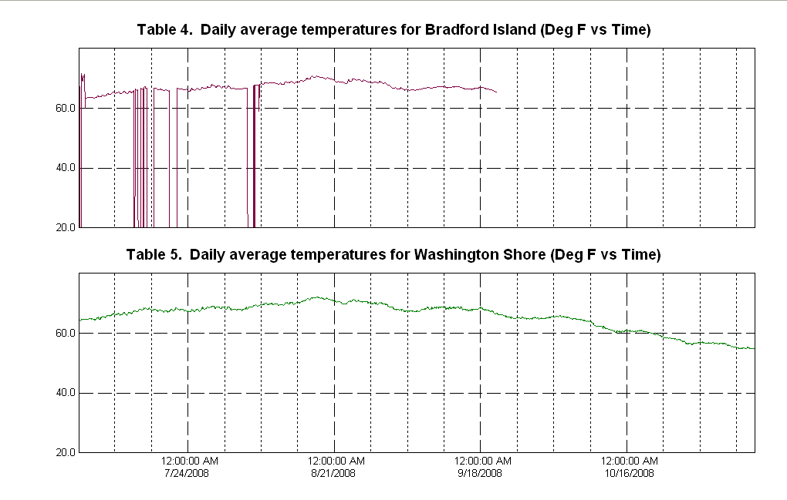
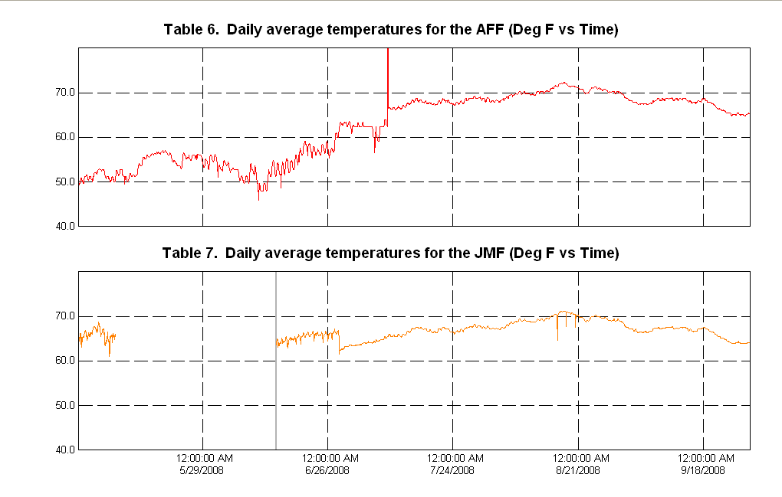
FISH FACILITY AND TURBINE OUTAGES
Table 8. Fish Facility Outages & Maintenance.

* Cascades Island exit was opened on 11 July to provide an exit for fish caught upstream of the Upstream Migrant Transportation channel (UMT) picket leads.
** The Washington shore exit was closed from 1756 until 1940 on 14 January to facilitate a search for a possible suicide victim in the fishway.

Table 9. Fish Unit Outages and Reduced Loads.

Fish units 1 and 2 were placed on standby at other times during the year to “float” trash away from the trash racks. When drawdown measured one foot or greater, fish units were shut down. An adjacent unit was then operated to pull trash away from the fish unit trashracks. This procedure helped prevent debris and silt from accumulating in front of the fish units. Most of the unit outages associated with the floating of trash and debris occurred between 2400 and 0300 to minimize impact on adult fish passage.
Table 10. Turbine Outages of at lease 24 hours.
FISH REMOVAL

Fish passage facilities and turbine units are taken out of service and dewatered to allow for inspection, preventative maintenance, repairs, and modifications. As facilities and turbine units are dewatered, project biologists, outside agency personnel, and other project personnel follow procedures outlined in the Fish Passage Plan and detailed in the Fish Salvage Plan to minimize impacts on fish. Fish recovered are typically released into the forebay above the new navigation lock. Salvaged sturgeon and juvenile salmonids, however, are released below the dam at Hamilton Island. The following is a summary of the number of fish that were removed during facility and turbine unit dewaterings. All fish were recovered in good condition unless otherwise noted.

Unit 18 draft tube (12/5/07): seven sturgeon.

Unit 14 tail logs (12/10/07): 12 sculpin, three catfish, three peamouth.

Bradford Island (12/17/07): one adult hatchery steelhead, one adult wild steelhead, eight juvenile hatchery steelhead, seven juvenile wild steelhead, one juvenile unclipped chinook, nine juvenile clipped chinook, 26 peamouth, six sculpin, three sturgeon, four smallmouth bass, six whitefish, three suckers, two lamprey, three trout, seven crawdads.

Bradford Island Junction Pool (12/17/07): three adult hatchery steelhead, two adult wild steelhead, 29 juvenile hatchery steelhead, one juvenile wild steelhead, two juvenile unclipped chinook, three juvenile clipped chinook, 38 juvenile shad, one whitefish, two pikeminnow.

Bradford Island A-branch (12/18/07): four sturgeon, 15 juvenile salmonids.

Bradford Island B-branch (12/18-19/07): six adult steelhead, two juvenile steelhead, 163 sturgeon.
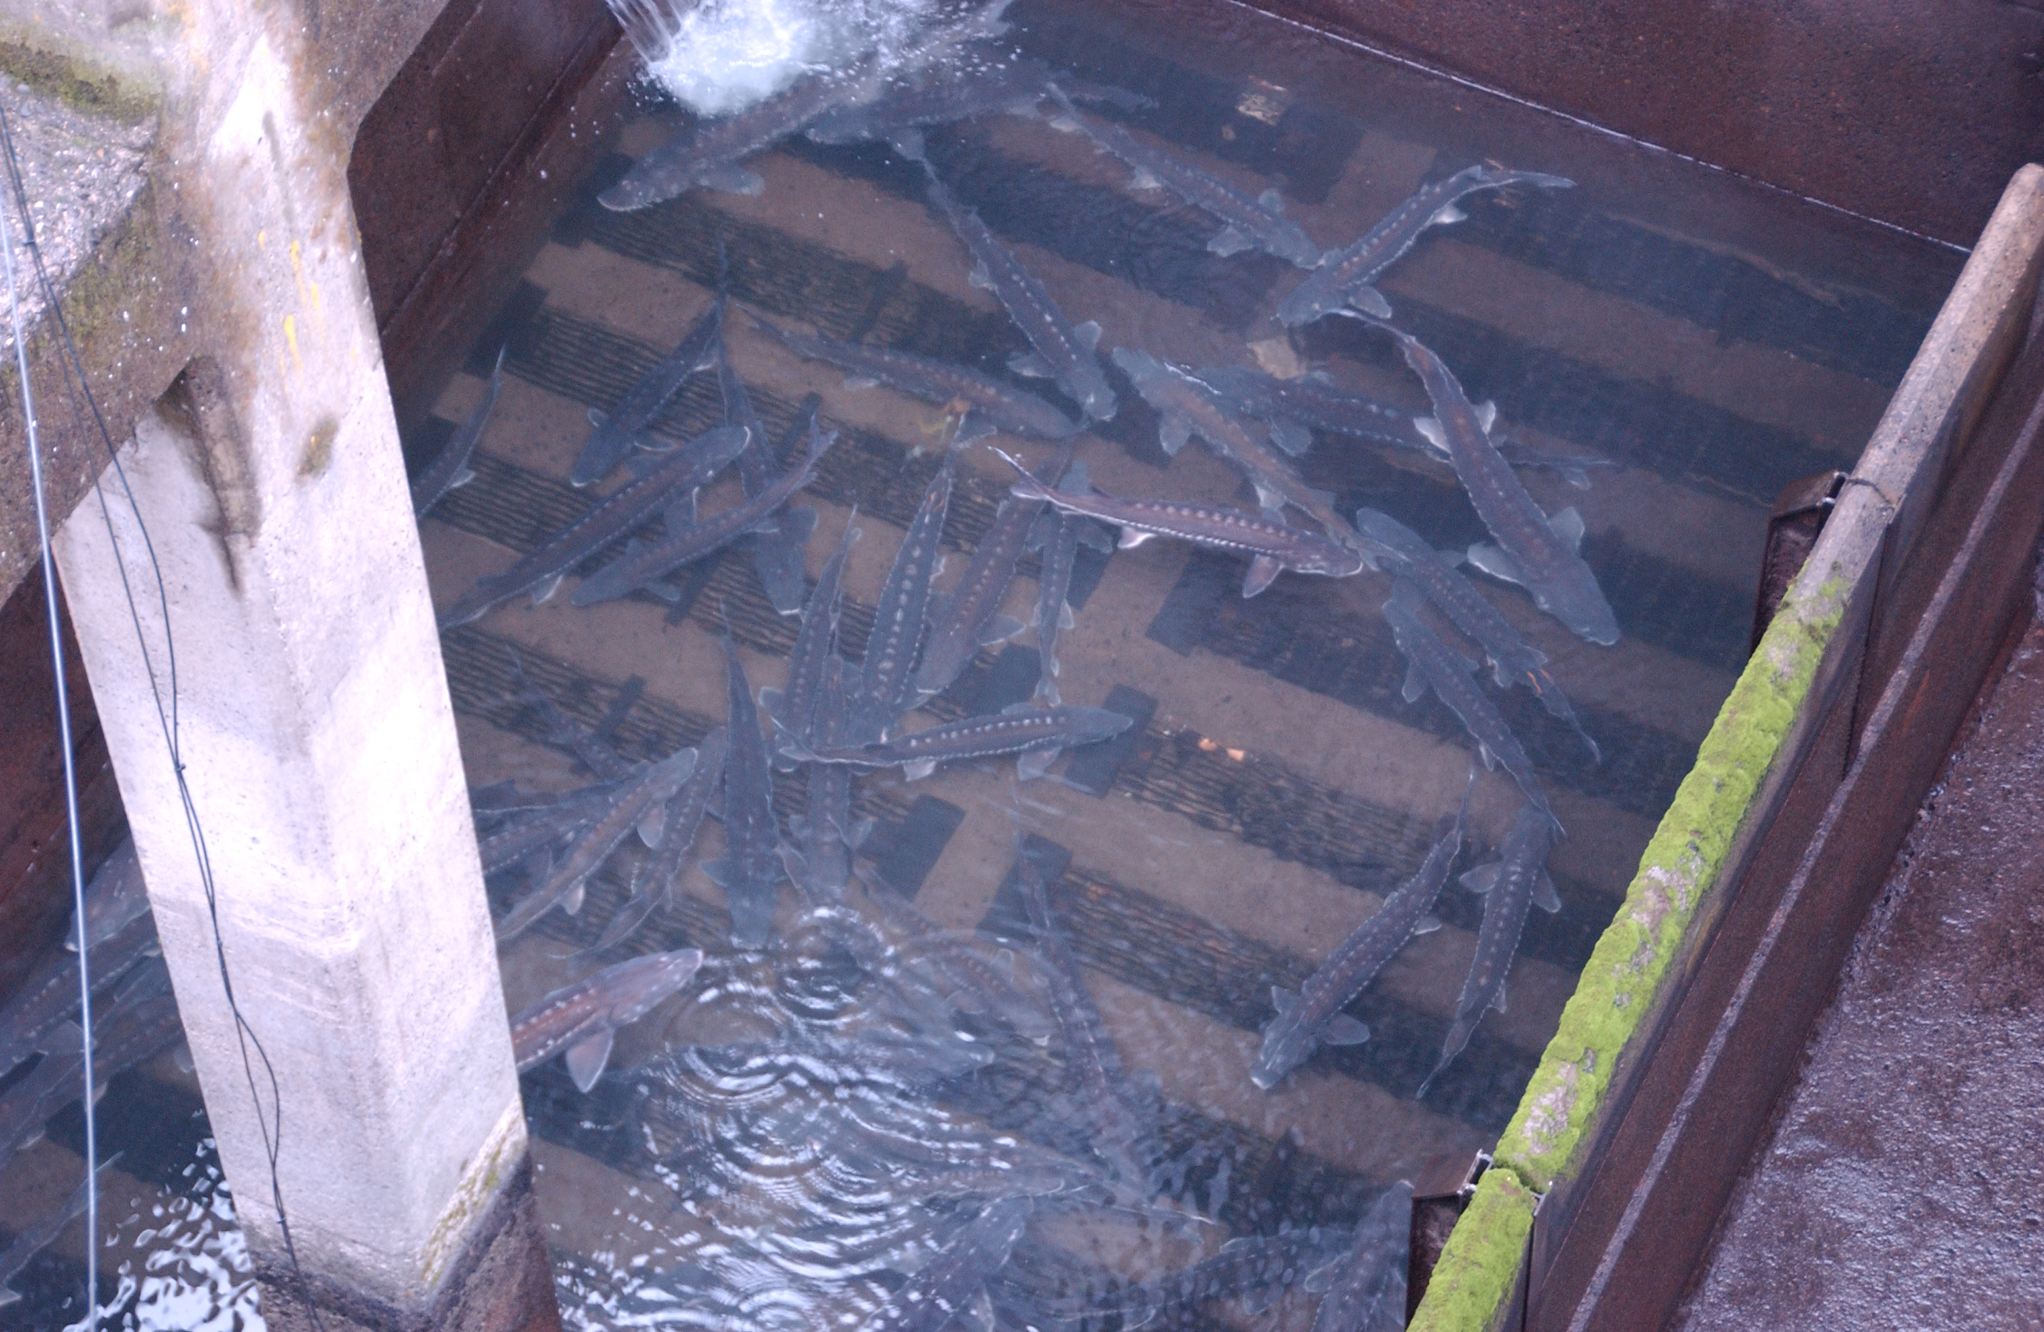

PH1 Downstream Migrant transportation channel (DSM1) (12/20/07): Eight juvenile Chinook, two bass, two stickleback, two sculpin, and one sucker were removed and released back to the river.

AFF (12/31/07): one juvenile wild steelhead, one bluegill, one sturgeon

Unit 1 tail logs (2/13/08): five sturgeon, one unclipped steelhead, 14 sculpin, four crayfish, one sucker, one juvenile Chinook

Unit 18 tail logs (2/21/08): 23 live sturgeon, two sculpin; two sturgeon mortalities observed.

Unit 16 draft tube (3/6/08): one 7-8’ sturgeon, two 5-6’ sturgeon, 21 other sturgeon

Unit 16 tail logs (3/31/08): 15 sturgeon and one catfish

Unit 3 draft tube (4/15/08): one chinook smolt and two fry

Unit 3 scroll case (4/18/08): 35 juvenile salmonids

Unit 3 tail logs (5/29/08): Nine sculpin, one catfish, two Chinook smolt mortalities

Unit 1 scroll case and draft tube (7/8/08): 150 juvenile salmonids, six adult shad, 11 adult lamprey, six 2-3’ sturgeon.

Unit 8 tail logs (7/14/08): Four juvenile chinook, one juvenile steelhead, four sculpin, two sturgeon, one bass.

Unit 1 tail logs (8/5/08): Two juvenile steelhead, one juvenile chinook, one adult unclipped chinook, four sturgeon, 12 sculpin.

Unit 9 draft tube (8/6/08): Four sturgeon, one lamprey, one catfish.

DSM1 (9/2/08): Two juvenile chinook, one juvenile steelhead, two sculpin

Unit 11 draft tube (9/30/08): 35 sturgeon, six catfish, three bullhead, one pikeminnow

Fishway Modifications (1996-Winter 2007/08)
POWERHOUSE ONE ADULT
2006-present. Sea lion exclusion devices (SLEDs) are installed at the fishway entrances to prevent sea lion access to the fish ladder.
2005/06. Bulkheads were installed in the orifice gate and telescoping gate slots. Gates were removed along with the associated electronic and mechanical equipment.
2005/06. Passive Integrated Transponder (PIT) tag detectors installed in four serpentine weirs in the Bradford Island fishway.
2004-present. Utilize ROVs for fishway inspections instead of divers.
2003/04. Installed new electronic velocity meter at the north end of the PH1CC.
2002/03. PH1CC orifice gates and telescoping gates are closed and disabled. Studies indicated more fish exited these gates than entered. Weir gates were left in service.
2001/02. Extra orifices in the overflow weirs were filled with concrete.
2000/01. PIT tag detectors installed in four orifice weirs in A-branch and four orifice weirs in
B-branch.
1998/99. FG3-10 through 17 disabled and filled with concrete. FG3-14 (at the junction pool) covered with metal plates instead of concrete.

POWERHOUSE ONE JUVENILE
2004-2007. DSM1 is disabled as a juvenile bypass route. Screens are not installed during fish passage season except from 15 September until 15 December for adult fallback. DSM1 runs south during this time.
2001-2003. Unit 8 extended submerged bar screens were deemed undesirable and replaced with standard STSs.
2001-present. The 2000 Biological Opinion (BiOp) required the removal of impediments to fish passage from the turbine environments. Removal and replacement of excess metal, with fish friendly alternatives, occurs as units go out of service for rehab.
2000-present. Turbine rehab involves installing minimum gap runners on all PH1 main units. Roughly one unit is completed each year. Units 1-6, 8, and 10 are completed. Units 7 and 9 will be finished in 2009.

POWERHOUSE ONE LAMPREY
2005/06. PIT tag detection and expanded lamprey ramp installed in the Bradford Island FV3-9 AWS channel.
2003/04. Lamprey ramp installed in the Bradford Island FV3-9 AWS channel.

CASCADES ISLAND FISHWAY/ UMT
2004-present. Utilize ROVs for fishway inspections instead of divers.
2004/05. UMT fish count window crowder and window cleaner removed.
2001/02. New diffuser covers built and installed.
2000/01. More PIT tag detectors installed in four orifice weirs.
1999/00. FG6-1 through 4 filled in with concrete.
1998/99. PIT tag detectors installed in four orifice weirs.
1996-2000. The UMT drain is blind flanged and no longer used.

CASCADES ISLAND LAMPREY
2005/06. Half duplex PIT tag detectors were installed along the picket leads to track lamprey.

POWERHOUSE TWO ADULT
2007/08 Manufactured new FOG SLEDs.
2006/07. Installed new staff gauges in the monoliths.
2006/07. AFF lamprey orifice gate removed due to pulley failure resulting in salmon passage blockage and dewatering difficulties.
2005-present. SLEDs installed at fishway entrances to prevent sea lion access to the fish ladders.
2005/06. AFF count window crowder removed due to structural failure.
2004-present. Utilize ROVs for fishway inspections instead of divers.
2004/05. Repaired the AWS conduit.
2004/05. Installed new velocity meter at South Upstream Entrance (SUE).
2004/05. PIT tag detectors installed in four serpentine weirs.
2004/05. AFF brail pool modifications made. The brail pool is now the primary recovery pool.
2003/04. AFF electrical upgrades complete.
2003/04. Picket leads for the triangle section were removed.
2002/03. Removed old metal staff gauge frames from monolith entrances.
2001/02. PIT tag detectors installed in eight orifice weirs, four upstream and four downstream of the AFF.
1999/00. AFF exit ladder equipped with orifice PIT tag detectors.

POWERHOUSE TWO JUVENILE
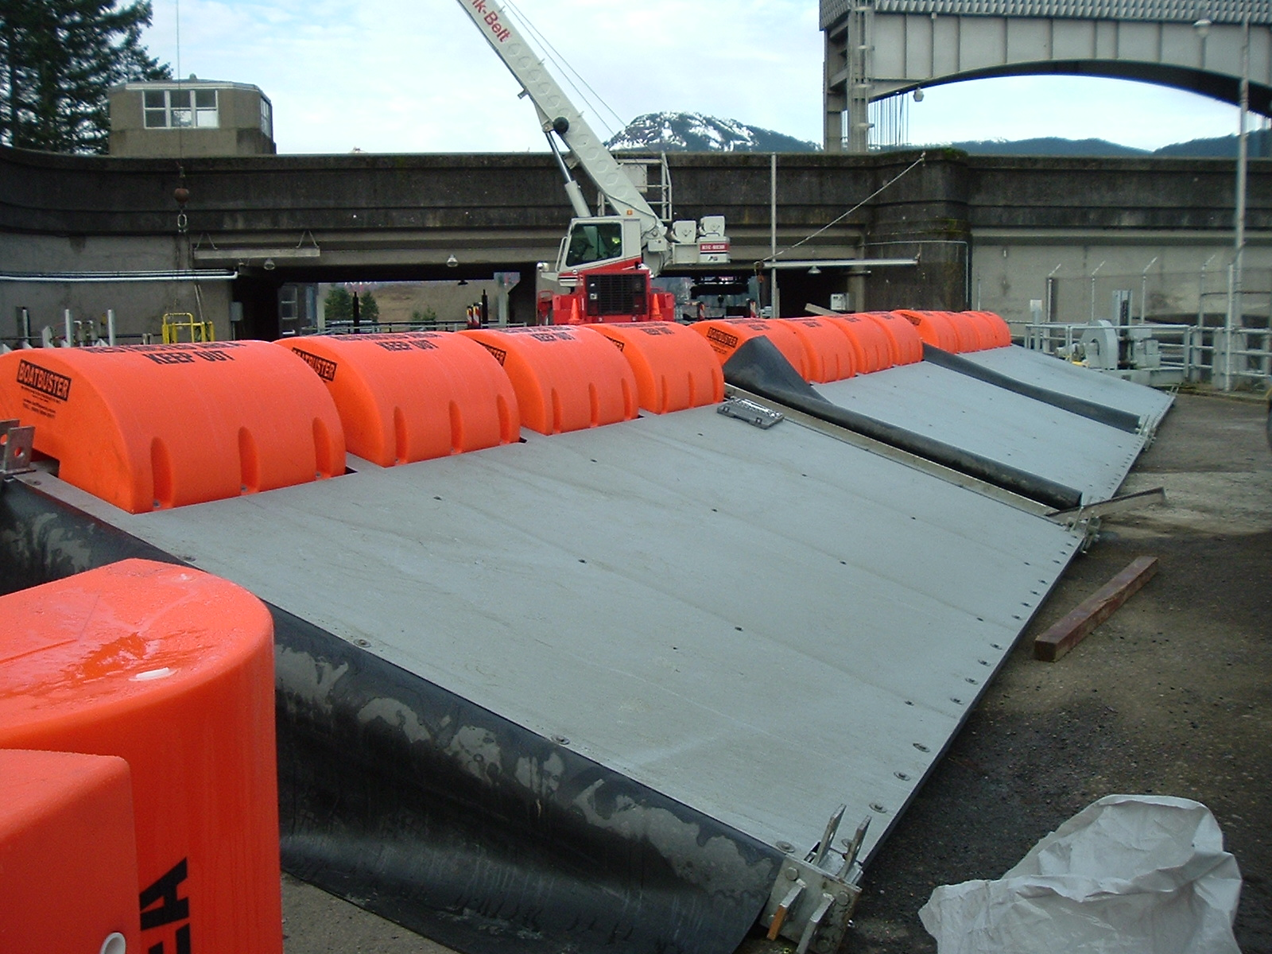
2007/08 Behavioral Guidance Structure (BGS) installed in PH2 forebay.
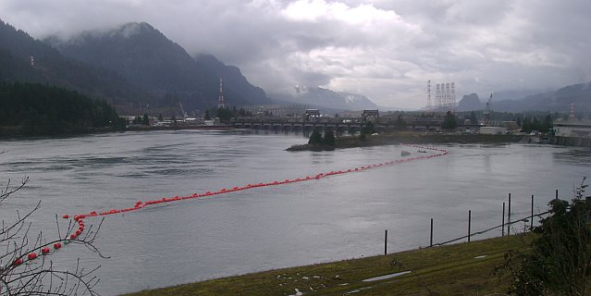
Assembled BGS panels.
BGS in PH2 forebay.
2007/08 PH2 Downstream Migrant transportation channel (DSM2) LED lights returned to halogen lights due to the unknown effects of LEDs.
2007/08. Units 14 and 18 are modified for new VBSs and improved FGE.
2006/07. New LED lights replace the halogen lights. The LED lights are cooler and will last years longer than the halogens. These lights were salvaged from DSM1.
2006/07. Units 11, 15, 16 are modified for new VBSs and improved FGE.
2005/06. B2CC PIT tag antenna installed.
2005/06. SMF full flow PIT tag antenna installed.
2005/06. Units 12 and 13 are modified for new VBSs and improved FGE.
2004/05. VBS modifications for Unit 17 result in screen failure. The design for the new VBSs is re-examined and redrawn.
2004/05. SMF Outfall hydrocannon piping is replaced.
2004/05. B2CC complete and online.
2003/04. Unit 17 VBSs and gatewells are modified to improve FGE. Modifications include gap closure devices on the STSs and modified VBSs.
2002/03. NOAA Fisheries fyke net frame is removed from the tailrace.
2002/03. Unit 15 gatewells are partially modified to improve FGE. Modifications include gap closure devices on the STSs.
2002/03. Biologists noticed places of ovality while inspecting the two mile pipe. The pipe has been surveyed every year since the issue was discovered.
2002-present. The 2000 BiOp required the removal of impediments to fish passage from the turbine environments. Removal and replacement of excess metal, with fish friendly alternatives, occurs as units come out of service for maintenance.
2001/02. Raised the DSM2 walkway grating to prevent fish from impacting it.
2001/02. Modified the DSM2 add-in screen to vertical bars to allow juveniles to move out of the add-in water and into the channel. The bars didn’t reach the walkway so a perforated plate was added later in the season to prevent adults from jumping into the add-in section.
2001/02. Flume covers were added over the switchgates. This was to encourage fish to stay in the main channel and not seek shade by swimming under the switchgates.
2000/01. Saltwater rearing moved into the SMF.
2000/01. Modifications were made to the primary dewatering structure drain pipe to divert more water into the wetlands. This reduced the flow fluctuations and air bubbles under the perforated plate in the primary dewatering structure.
1998-2000. SMF construction completed. The facility goes online.

POWERHOUSE TWO LAMPREY
2006/07. Lamprey ramp installed in the Washington Shore FV6-9 AWS channel.

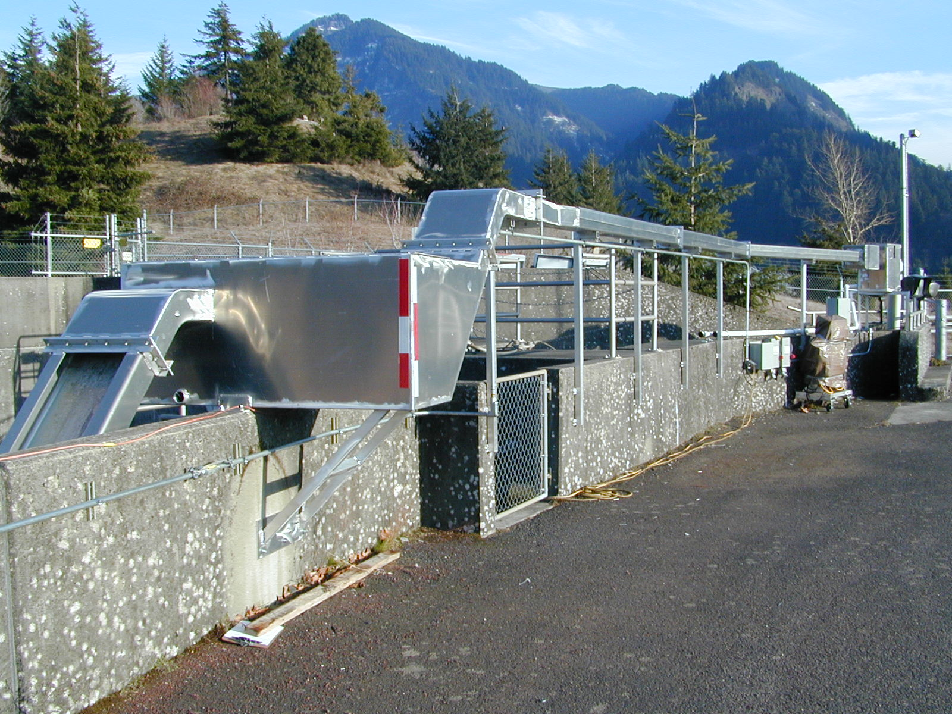 Washington Shore lamprey ramp.

2004/05. Lamprey ramp installed at North Downstream Entrance (NDE).
2000/01. Lamprey plates are installed over the Washington Shore diffuser grates.

BASS LAKE
2006. The leaking drain is repaired. The lake holds water and coho are seen spawning in the outlet (Moffett Creek) of Bass Lake. The salvaged logs create log jams over the sink hole.
2004. Salvaged logs are placed in Bass Lake to provide habitat.
GLOSSARY

AFF----- Adult Fish Facility. Lab associated with the Washington Shore ladder. Adult fish are trapped for research purposes.
AWS-------------------------Auxiliary Water Supply.
B2CC------------------------Powerhouse Two Corner Collector. A surface bypass system located in the southern corner of the Bonneville Second Powerhouse forebay.
BGS--------------------------Behavioral Guidance Structure. Located in the PH2 forebay.
BI--- Bradford Island Fishway
BiOp Biological Opinion.
BPA Bonneville Power Administration
CI-- Cascades Island Fishway
Collection Channel(CC) Part of the adult fishway spanning the length of the downstream side of each powerhouse.
DSM1 Downstream Migrant transportation channel (PH1). Transport channel for adult fallback and steelhead kelts from gatewell orifices to the ice and trash sluiceway.
DSM2 Downstream Migrant transportation channel (PH2). Transport channel for juvenile fish from gatewell orifices to the juvenile transport pipe.
ERG Emergency Release Gate. Located in DSM2.
FG Diffusion gate.
FGE--------------------------Fish Guidance Efficiency.
FOG Floating Orifice Gate.
Forebay That area of a reservoir immediately upstream of a dam.
FPC Fish Passage Center.
FPP Fish Passage Plan.
FV Fish Valve.
ITS Ice and Trash Sluiceway.
JBS Juvenile Fish Bypass System.
JMF--------------------------Juvenile Monitoring Facility. Lab associated with the PH2 JBS.
LPS Lamprey Passage System
MW Megawatt
NDE----- North Downstream Entrance. Refers to one of the four large overflow weir adult fishway entrances at PH2.
NUE North Upstream Entrance. See NDE.
NOAA National Oceanic and Atmospheric Administration.
OOS Out Of Service.
PH1 Bonneville Powerhouse One.
PH2 Bonneville Powerhouse Two.
PIT ------ Passive Integrated Transponder. A tag inserted into juvenile and adult fish. Detectors are installed at all fish passage systems.
Project Bonneville Lock & Dam.
ROV--------------------------Remotely Operated Vehicle.
SDE South Downstream Entrance. See NDE.
SLED Sea Lion Exclusion Device
SUE South Upstream Entrance. See NDE.
STS Submersible Traveling Screen.
Tailwater/ tailrace The portion of a river immediately downstream of a dam or powerhouse.
UMT----- Upstream Migrant Transportation channel. This channel connects Cascades Island ladder to Washington Shore ladder through PH2.
VBS Vertical Barrier Screen.
WDFW Washington Department of Fish & Wildlife.
WS ---------------------------Washington Shore fishway.
REFERENCES

2007. Fish Passage Plan for Corps of Engineers Projects. U. S. Army Corps of Engineers, Northwestern Division, Portland, Oregon.

2008. Fish Passage Plan for Corps of Engineers Projects. U. S. Army Corps of Engineers, Northwestern Division, Portland, Oregon.

2007-2008. Weekly reports for Bonneville Dam. U.S. Army Corps of Engineers, Portland District. Bonneville Lock and Dam.

2007-2008. Daily fishway inspections for Bonneville Dam.

